Receiver Module & Transmitter module G2 description

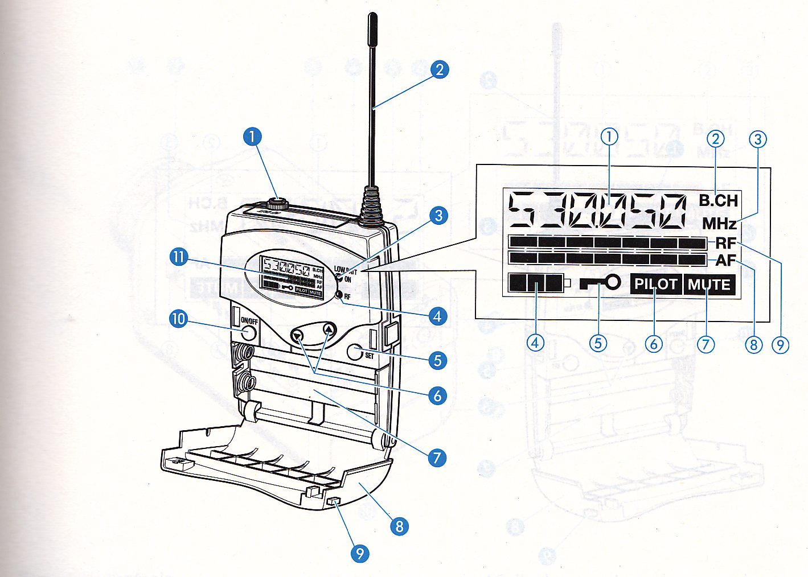

- Ear Piece socket; 3.5mm jack socket on receiver/Microphone socket on transmitter

- Aerial

- Red LED to show on & battery condition

- Green LED shows RF signal received level

- Menu button & Set

- Scroll button for menu

- Battery compartment (use only Alkaline batteries)

- Battery cover

- Unlock button

- On/off button. (when in menu can be used as escape/cancel)

- LC Display

- Mute switch (located next to microphone socket on transmitter)

How to set up and operate the radio sets

- Both the transmitter and receiver must be set to a wave length between 863.100 to 864.900 MHz.
- The RFU preferred channel is 864.500
- To set the transmitter to this frequency follow the procedure given below;
- Open battery cover and switch on using button 10 (on/off)
- Press button 5 (set) to open menu
- Use button 6 and scroll up to go BANK
- Press button 5, with button 6 scroll to number 1, press button 5 again and you will see stored and a channel number, if it is not 864.500 follow the instructions below.
- Now scroll down with button 6 to TUNE and press button 5
- The screen now shows the channel selected.
- If the display is not 864.500 use button 6 to scroll to this number 864.500. Press button 5 to store.
- With button 6 scroll up to Channel, press button 5 to open, if display is 864.500 press button 5 to store.
- With button 6 scroll down to SENSIT and press button 5, scroll with button 6 to -20db and press button 5. (-10db gives loudest output. -30 gives lowest output) To get the best balance in sound output with input to receiver sensit has to be balanced with AV out) Loudest sound to earpiecce = Sensit on -10db with AV out on +12
- With button 6 scroll down to PILOT press button 5 display should show PLT ON. If it shows PLTOFF use button 6 to scroll to PLTON, then press button 5
- With button 6 scroll down to EXIT and press button 5 and the screen will show the selected channel (863.100) battery condition 1-2 or 3, and PILOT.
- The transmitter is now set up correctly.

- To set the receiver to the frequency 864.500 follow the procedure given above;
- If the screen on the receiver shows MUTE in the bottom right hand corner the MUTE switch on top of the transmitter is activated, this must be turned off with the button next to the microphone socket.

Notes for reference;

- If the screen shows the battery symbol as only one square when you switch on the sets then change for new batteries. Alkaline batteries should last for about 3 matches of 80 minutes.
- Pilot; it is most important to switch this on in both sets. The pilot from transmitter has a unique setting to prevent interference from other radio sets that are working on the same channel in close proximity to each other. (if you wish to listen in to another set do not use pilot)
- If the squelch is set to Hi the receiving distance is greatly reduced and you will lose the referee voice when he turns away or the distance gets too far.
- If you find that the volume is to high on the receiver enter the menu and go to AF OUT and reset to a lower number +3 or +6.

